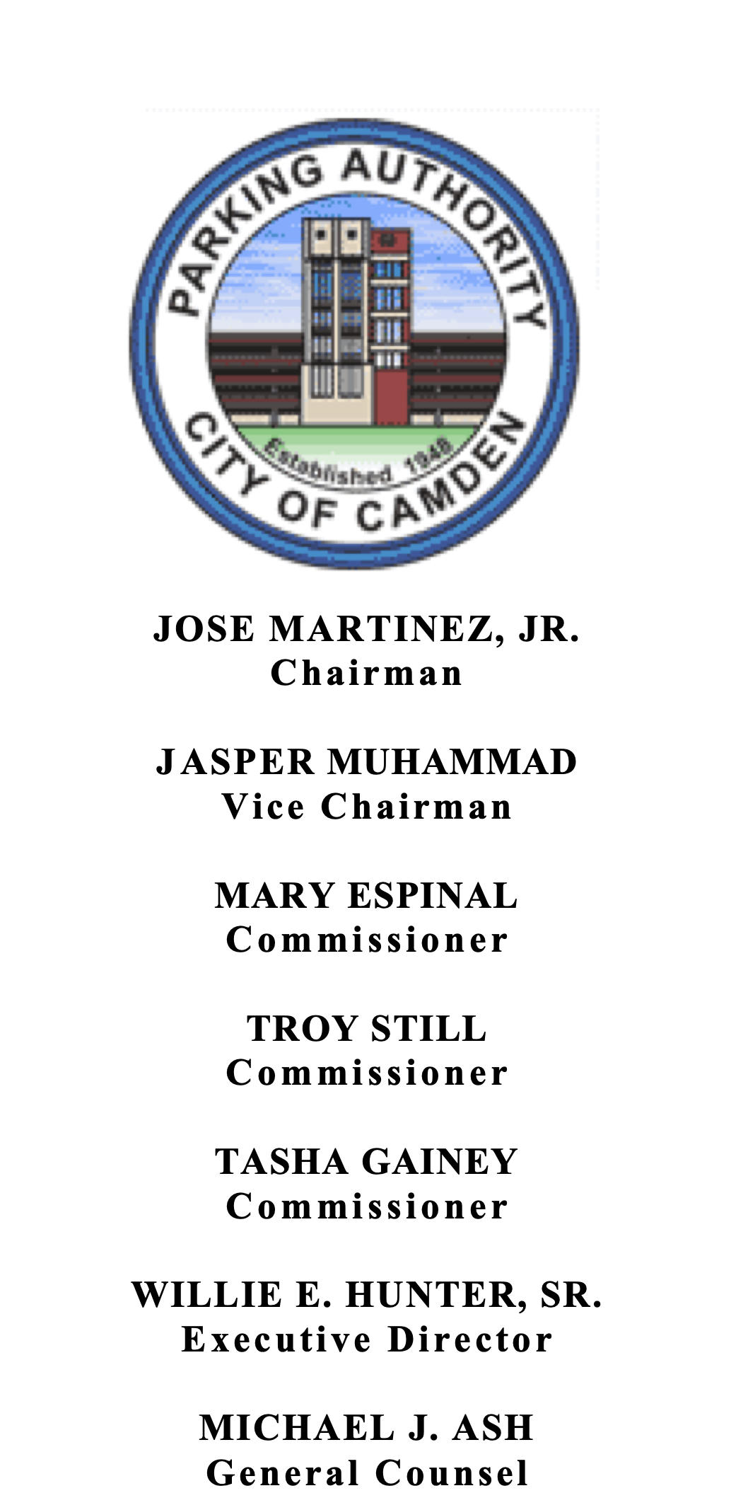

THE PARKING AUTHORITY OF THE CITY OF CAMDEN

10 DELAWARE AVENUE, CAMDEN, N.J. 08103

TEL. (856) 757-9300 • FAX (856) 964-9317

June 27, 2022

LEGAL NOTICE

THE PARKING AUTHORITY

OF THE CITY OF CAMDEN
MEETING NOTICE

In accordance with N.J.S.A 10:4-12, the “Open Public Meetings Act,” you are hereby notified of a Virtual Meeting of the Parking Authority of the City of Camden will be held on Monday, June 27, 2022, at 2:00 P.M. at the Parking Authority City of Camden, Administration Conference Room, 1st Floor, 10 Delaware Avenue, Camden New Jersey.

ADVISORIES

This meeting will be conducted by electronic means in accordance with the “Senator Byron M. Baer Open Public Meetings Act” of 2020, which explicitly permits a public body to conduct a meeting electronically during a state of emergency. Governor Murphy issued Executive Orders 103 and 107 declaring a “Public Health Emergency and State of Emergency” and directing residents to quarantine and practice social distancing.

Any questions can be directed to the Parking Authority Administration main line during business hours at 856-757-9300 or via email at info@camdenparking.net.

The Agenda for the Meeting to the extent presently known is as follows:

OPEN SESSION

1. Call to Order
- Roll Call
- Reading of Public Meeting Statement
4. Public Comment
5. Adoption of Minutes
6. Directors’/Consultants’ Reports
7. Adoption of Resolutions
8. Old Business
9. New Business
10. Adjournment

