General Instructions and Specifications

Parking Authority of City of Camden

Request for Proposal to Provide Photovoltaic

System Installation

May 2022

Prepared by:



Table of Contents

PART 1 PROJECT 3

1.1 SCOPE OF WORK 4

1.2 RFP AND CONSTRUCTION SCHEDULE 5

1.3 RFP Instructions 5

1.4 QUALIFICATIONS AND PROPOSAL REQUIREMENTS 6

1.5 SUMMARY 7

1.6 SUBMITTALS 8

1.7 QUALITY ASSURANCE 9

1.8 WARRANTY 9

1.9 EXTRA MATERIALS 10

PART 2 PRODUCTS 11

2.1 GENERAL COMPONENT REQUIREMENTS 11

2.2 PV MODULES 11

2.3 BATTERY STORAGE SYSTEM 12

2.4 DISCONNECT SWITCHES 12

2.5 WIRING/CONDUCIT ELECTRONIC MOUNTING 12

2.6 DATA ACQUISITION/METERING 13

PART 3 EXECUTION 14

3.1 INSTALLATION REQUIREMENTS 14

3.2 INSTALLATION STANDARDS 15

3.3 DELIVERY, STORAGE, AND HANDLING 15

3.4 LABELING AND IDENTIFICATION 16

3.5 CLEANING AND TESTING 16

PART 4 PROCEDURES 17

4.1 SYSTEM INSPECTION AND SAFETY CHECKS 17

4.2 DOCUMENTATION 17

4.3 TRAINING 17

4.4 REQUIREMENTS 17

APPENDICES 18

# PART 1 PROJECT

Through the issuance of this Request for Proposals (RFP), the Parking Authority of City of Camden (“PACC” or “Authority”) is seeking an experienced Firm to submit a competitive proposal to deliver the turnkey installation of Photovoltaic (PV) Systems at their Theodore “Teddy” Hinson Waterfront Garage, located at 10 Delaware Ave, Camden, NJ. PACC is interested in PV parking canopies. The PV System may be paired with an Energy Storage System (ESS). The specific portions of each property upon which the various systems may be proposed are included in “Appendix C – Project Concept Maps” This PV project is intended to be the first phase of many as the Authority continues to expand its energy resiliency efforts.

The Authority has established minimum technical installation and performance requirements for the PV System considered for installation. Projects submitted for review by the PACC must include a conceptual layout illustrating the general arrangement of the PV System components, as well as an energy generation summary to function as the Basis for Design (BOD) for the proposed PV System. The PV system conceptual layout shall include PV modules and site-specific interconnection equipment and inverters. Proposers shall note that final project design and engineering is not provided herein, but will be undertaken by the successful Firm.

## 1.1 SCOPE OF WORK

1. A. This specification includes the minimum technical requirements for the design, installation, testing, and commissioning of the proposed PV System located at the following facilities:
2. **Theodore “Teddy” Hinson Waterfront Garage 10 Delaware Ave, Camden, NJ 08102**
   1. Proposer is required to submit detailed information for all materials necessary to deliver the proposed PV System as per the format noted herein.
      * + 1. B. Proposer shall provide all work necessary to install a complete PV System, including but not limited to engineering, design services, permits, materials, labor, equipment, installation, utility interconnection, inspection, commissioning, and Permission to Operate (PTO) for a complete PV System located within the identified areas.
   2. C. The Contractor’s work is limited to the PV System, Electric Vehicle (EV) Charging Stations, Energy Storage System, and appurtenances.
   3. D. The Contractor shall provide a completed Proposal Cost and Pricing Sheet, as provided in Appendix B.
   4. E. Contractor will be responsible for all permits required by the Authorities Having Jurisdiction and receipt of Certificate of Approval (C of A).
   5. F. It is noted that the terms “Proposer”, “Contractor”, “Company”, and “Respondent” are all used interchangeably in this specification. All of these terms apply to the successful Contractor and contract holder once awarded.
   6. G. Contractor shall abide by all National Electric Code (NEC) codes, New Jersey Board of Public Utilities (NJBPU) rules and regulations, and New Jersey Clean Energy Program (NJCEP) requirements with the design and installation of the PV System.
3. H. The PV design will assure that any PV System failure does not affect the quality or supply of electricity provided by PSE&G to the PACC properties.
4. I. Proposer will be responsible for all incentive applications, permits, submittals, interconnect application, and associated fees required by the local enforcement Authority Having Jurisdiction and/or Department of Community Affairs, PSE&G, New Jersey Department of Environmental Protection (NJDEP), and PJM.
5. J. Proposer will conform to the insurance requirements of the Owner. Proposer shall be responsible for the protection of all existing site/building components within and adjacent to the areas of this work.

While the information provided herein is believed to be accurate and reliable, neither the Parking Authority of City of Camden nor PACC’s Consultants make any representations or warranties, expressed or implied, as to the accuracy or completeness of such information. The Parking Authority of City of Camden reserves its right to reject all Proposals and not award a contract.

*Note: All information contained in or supplied with this RFP is proprietary and confidential. Any use of this information, except for the sole purpose of preparing a response to this RFP, is strictly prohibited.*

## 1.2 RFP AND CONSTRUCTION SCHEDULE

The RFP, Permitting and Approvals, and Construction Schedule is as follows:

|  |  |
| --- | --- |
| **Milestone** | **Date** |
| RFP Publication Date | **May 27, 2022** |
| Pre-bid Conference and Site Inspection | **May 31, 2022 at 11am** |
| Last Day to Submit Clarifying Questions | June 3, 2022 |
| Publication of Responses to Questions | June 10, 2022 |
| RFP Due | **June 14, 2022 at 4pm** |
| Potential Post-Evaluation Interviews, Contract Negotiations, and Executed Letter of Intent | End of June |
| Anticipated Execution of Contract | June 30, 2022 |
| Filing of applications for all necessary Permits and Approvals | July 1, 2022 |
| Submission of interconnection Agreement | July 5, 2022 |
| Start of Construction | June 30, 2022 |
| Completion of Construction | August 31, 2022 |
| Permission to Operate (PTO) Approval from PSE&G | **September 22, 2022** |
| Receipt of NJ TREC Certification Number | TBD |

*Note: The successful Respondent shall submit an updated project schedule to Parking Authority of City of Camden and their Consultants at least three weeks prior to the proposed start of construction.*

## 1.3 RFP Instructions

1. A Pre-Bid Conference will be conducted on the date set forth in Section 1.2 at 10 Delaware Ave, Camden, NJ. All interested Proposers are encouraged to attend the Pre-Bid Conference and Site Inspection.
2. Proposers may submit written questions by the deadline set forth in Section 1.2 during the RFP process. Whether and when to respond to questions is entirely within PACC’s discretion. Questions should be submitted formally via email to Dionne Banks at dbanks@camdenparking.net with the subject line “Parking Authority of City of Camden PV System RFP Q&A Inquiry.”
3. Parking Authority of City of Camden retains the absolute and unabridged right to alter the requirements of the RFP in any respect, at any time prior to the award of contracts, including by withdrawing the RFP, changing, adding, or deleting its scope.
4. Proposers may submit their RFP response formally to Parking Authority of City of Camden by email at [dbanks@camdenparking.net](mailto:dbanks@camdenparking.net) .

## 1.4 QUALIFICATIONS AND PROPOSAL REQUIREMENTS

**A. Qualifications**

1. The successful Firm shall have a minimum of three years’ experience signing, procuring, and installing PV Systems. The successful Firm shall have design and installed a minimum of three PV systems with a total installed project capacity of more than five (5) MW.
2. Provide a minimum of three US customer references
3. The successful Firm shall properly bond and insure all work, equipment, material, and individual onsite in accordance with industry standards
4. Design and construction shall be by or under the responsible charge of a Professional Engineer, licensed in the state of New Jersey, who has experience with facility electrical and energy systems.

**B. Proposal Requirements**

Each respondent shall submit the following information with their bid response:

1. Provide address and contact information for corporate office. Provide address and contact information for local office.
2. Identify Project Manager and any Key Personnel for this project. Submit resumes for each Project Manager and any Key Personnel. The Project Manager must meet the experience requirements set forth above.
3. For each Subcontractor, identify company name, address, contact information, and project role(s), and describe experience of each Subcontractor with PV Systems.
4. Provide a customer name, contact information, and brief description of at least three completed PV Projects in New Jersey. Limit each description to no more than two pages.
5. Completed Proposal Cost and Pricing Sheet in Appendix B.
6. A general description of the proposed system and minimum technical requirements are identified herein. Proposals shall include preliminary drawings, PV, EV, and PV layouts, and manufacturer information (cut sheets) for each major system component. Include any other information that will help the Authority to gain an understanding of the proposed PV System, along with its features and benefits. Discuss any ongoing maintenance considerations and/or recommendations. Discuss any environmental benefits generated from the project.
7. Provide an estimated timeline for project implementation.
8. **C. Evaluation Criteria**
   1. 1. Experience of design/installation firm and Subcontractors in completing similar projects;
   2. 2. Experience of project team (Project Manager and Key Personnel) in completing similar projects;
   3. 3. Knowledge of New Jersey laws and regulations for permitting and constructing/installing similar projects;
   4. 4. Knowledge of New Jersey renewable energy and PV System programs, requirements, regulations, and financial incentives;
   5. 5. Proposed PV system design, including energy generation, power quality, resiliency, and reliability benefits;
   6. 6. Responsiveness and understanding of the scope of work/services and site conditions (including but not limited to existing condition and upgrades that may be necessary);
   7. 7. Environmental benefits of the proposed PV System;
   8. 8. Cost and value of the commercial offer as indicated in Appendix B and;
   9. 9. Clarity and conciseness of submittal.
9. The Parking Authority of City of Camden will evaluate submissions and develop a “short list” of the most qualified responses with the greatest benefit to the Authority. Proposers may be required to attend a post-evaluation interview and present their proposal for questions and requests for clarification submitted by the Parking Authority of City of Camden’s evaluation team.

## 1.5 SUMMARY

1. Systems Description- The PV System will include:
2. PV Modules: All PV modules must be manufactured from the below list of approved, bankable companies. A manufacturer not found on this list may be used if pre-approved by the Parking Authority of City of Camden and its consultants.



Note: Modules not shown above submitted for consideration are subject to approval.

1. Mounting System: Flat rooftop mounting systems shall be ballasted. PV carport systems shall be custom engineered to specific site conditions with high strength steel with corrosion protection.
2. Inverters: All inverters shall meet or exceed a maximum efficiency of 98.6%, CEC efficiency of 98%. All inverters shall include a minimum ten-year warranty for parts and labor.
3. Combiner Boxes: Combiner boxes shall have the following characteristics: NEMA 3R enclosure, 10A input, 1,000 VDC, rapid shutdown, and UL listed.
4. Disconnects: All disconnects shall be fused.
5. Battery Storage: Battery storage must be backup-power capable and guaranteed to last for 10,000 cycles or 10 years. All components and systems must be UL Listed. Battery storage should be sized with approximately one kWh of power per nameplate kW of the system.
6. Generator: Generator shall be natural gas DEP permitted to operate continuously.

## 1.6 SUBMITTALS

1. Shop Drawings Package

Shop drawings shall be provided for the Parking Authority of City of Camden, Consultant and code enforcement compliance review for the host site. The Contractor shall prepare the shop drawing package including the following items within ten business days from the receipt of written notice to proceed:

1. Project schedule;

2. PV array installation and string diagrams;

3. Single-Line Drawing;

4. Equipment cut sheets/product data, including data on features, components, ratings, and performance for PV modules, mounting structure, combiner boxes, inverter, kWh meter, Data Acquisition System, optimizers, Energy Storage System, EV Charging Stations, and Generator, if applicable;

5. Installation details, including mounting method and location of combiners and other equipment;

6. Equipment staging and material storage plan;

7. Crane lift plan and;

8. Roof protection plan.

1. Health and Safety Plan

The Contractor shall submit a Health and Safety Plan within ten days from receipt of written notice to proceed and observe all prudent and standard industry safety practices required for performing construction work of this type including all applicable OSHA standards. The Health and Safety Plan shall include building occupant safety considerations and planning for building/occupant communication regarding construction activities.

1. Shop Drawings: Indicate fabrication details, dimensions, weights, loads, required clearances, method of field assembly, components, and location and size of each field connection. Include design calculations, wiring diagrams/string maps, locations of conduit runs, and mounting details for components.
2. Structural engineering services shall include, but may not be limited to: existing structural member loading/evaluation, field survey of existing structural members, design plans, design calculations, wind load analysis, snow drift analysis, impact of the System weight to existing structural systems, ballast design/impact, seismic design analysis, material staging limits/areas on roof, shop drawings, any information requested by the Authority, etc.
3. Field Test and Observation Reports: Indicate and interpret test results and inspection records relative to compliance with performance requirements.
4. Certified Summary of Performance Tests: Demonstrate compliance with performance criteria.
5. Factory Test Reports: For units to be shipped for this project, showing evidence of compliance with specified requirements
6. Start-up, Testing, and Commissioning Plan- include the following:

1. Start-up Procedures;

2. Testing Procedures and;

3. Commissioning Plan.

1. Maintenance Data – include the following:

1. List of tools and replacement items recommended for storage at the project for ready access. Include part and drawing numbers, current unit prices, and source of supply.

2. Detailed operating instructions for both normal and abnormal conditions.

## QUALITY ASSURANCE

1. All Contractors and workers used by the Contractor must be licensed and bonded to perform these services in the State of New Jersey.
2. All Professional services concerning delegated design utilized by the Contractor must be licensed in the State of New Jersey.
3. All PV modules shall be individually tested and certified at the factory.
4. All equipment and materials shall be new, unused, and free of defects.

## 1.8 WARRANTY

1. General Warranty: Special warranty specified herein shall not deprive the Client of other rights Client may have under other provisions of the Contract Documents and shall be in addition to, and run concurrent with, other warranties made by Contractor under requirements of the Contract Documents.
2. Special Warranty: Written warranty, executed by manufacturer agreeing to repair or replace PV equipment and system components that fail in materials or workmanship within specified warranty period, at no cost or expense to PACC. Contractor shall obtain industry standard, manufacturer equipment warranties.

1. PV Modules – Modules shall come with a one-year warranty that guarantees replacement module for any module defect caused by materials or by workmanship at the factory. Module shall be covered by a power warranty that guarantees module power will be within ten percent of original power after twenty years of operation.

2. Mounting System – Manufacturer shall warrant the mounting system hardware to be free from defects in material and workmanship for a period of one year.

3. Combiner Boxes – Manufacturer shall warrant the Combiner Boxes to be free from defects in material and workmanship for a period of one year.

4. Inverters – Manufacturer shall warrant the inverters to be free from defects in material and workmanship for a period of ten years.

## 1.9 EXTRA MATERIALS

1. Furnish extra materials described below that match products installed and that are packaged with protective covering for storage and identified with labels describing contents.

1. Furnish Fuses: One for every ten of each type and rating installed on the project, but not less than one of each.

# PART 2 PRODUCTS

## 2.1 GENERAL COMPONENT REQUIREMENTS

1. Outdoor components must be made with corrosion-proof materials such as stainless steel, galvanized steel, and aluminum.
2. The use of wood products pressure treated or otherwise is not acceptable.
3. Electrical components shall be designed for 1,000 Volt System Voltage or greater.
4. All materials that are used outdoors shall be sunlight and UV resistant.
5. Materials shall be designed to withstand the temperatures to which they are exposed.
6. Only stainless steel, galvanized steel, and aluminum fasteners shall be used.
7. Structural members shall be corrosion resistant stainless steel, galvanized steel, and/or aluminum.
8. All electrical equipment shall be rated for the current and voltage ratings necessary for the application.
9. Wind uplift resistance shall exceed the regional wind specification as determined by the local code enforcement and/or authority having jurisdiction, and must be verified in writing by a Professional Engineer licensed in the State of New Jersey.
10. PV installation shall not unreasonably restrict access to building components, equipment, or access.
11. All outdoor inverters shall have an enclosure rating of NEMA 4 or 4X. All indoor equipment shall have an enclosure rating of NEMA 12 or greater.
12. PV System controls and data acquisition system should be open-architecture, be compatible with existing and future Building Management Systems (BMS), and have the ability to be virtually connected to future PV Systems on the property utilizing an interoperable SCADA System.

## 2.2 PV MODULES

1. PV System hardware must be selected based upon a thirty-year (30) system design life.

1. PV modules and system equipment shall be mounted to prevent pooling of water. PV modules shall be mounted in a generally southern orientation to improve performance.
2. PV modules and installation materials considered hazardous materials, defined by the New Jersey Department of Environmental Protection, are not acceptable for use.
3. Grounding connections to modules shall be arranged such that removal of a PV module does not interrupt ground connection to other modules.

## 2.3 BATTERY STORAGE SYSTEM

1. Battery Storage Systems must be UL Listed.
2. Battery Storage Systems must run in parallel to the grid

## 2.4 DISCONNECT SWITCHES

1. AC Disconnect Switches – The inverter disconnect shall be a heavy duty fused disconnect, rated for use, with three-pole plus isolated neutral and ground. Fuses shall also be class RK5, 1000VAC, with a minimum interrupt capacity of 65kA.
2. DC Disconnect Switches – The DC disconnect(s) shall be 1000 VDC, fused, rapid-shutdown, and heavy-duty safety switch(es).

## 2.5 WIRING/CONDUCIT ELECTRONIC MOUNTING

1. All system wiring shall be **copper only** and in accordance with Section 690 of the NEC, as well as manufacturer’s wiring guidelines for wiring sizes and connections. The wires used shall have a temperature rating of 90° C or higher.
2. Outdoor electrical conduits shall be aluminum cable tray or rigid galvanized, with NEMA 3R enclosures and watertight connections. Indoor conduits shall be Electrical Metallic Tubing (EMT).
3. Exposed cables shall be minimized and shall be UV resistant.

## 2.6 DATA ACQUISITION/METERING

1. The Data Acquisition System (DAS) shall be AlsoEnergy’s Deck Monitoring or approved equal. The DAS equipment will be provided by the Contractor as part of the PV system. The DAS shall include instrumentation that measures and records environmental and PV system performance conditions, including ambient temperature, wind speed, plane or array of solar irradiation, and AC system power output.
2. The DAS shall include a data-logger, modem for data retrieval, NEMA 4 enclosure, temperature measuring device, anemometer, and solar sensor. AC kWh measurement equipment must be revenue grade.
3. DAS system must be designed and installed to meet interoperability requirements within PACC’s existing Building Management System.
4. The Contractor to provide educational/promotional TV monitor to demonstrate real-time Internet digital display information. TV to be a minimum of 50’’ flat screen unless otherwise approved by PACC. This information must also be available to post on the Parking Authority of City of Camden website.
5. The Contractor shall install the DAS system in compliance with manufacturer’s requirements. Upon completion, the Contractor shall provide a transition of the administrative control and responsibility from the Contractor to the Operations and Maintenance (O&M) provider.
6. The DAS shall have real-time Internet digital display of the following information:
7. 1. Instantaneous system output in kW;
8. 2. Instantaneous irradiation in watts/square foot;
9. 3. Instantaneous ambient temperature;
10. 4. Instantaneous wind speed;
11. 5. Daily system output in kWh – Any day and day to hour;
12. 6. Monthly system output in kWh – any month and month to date;
13. 7. Annual system output in kWh - any year and year to date;
14. 8. Graphical comparison of projected system output to actual output’;
15. 9. Energy cost savings and;
16. 10. Environmental impacts, including carbon dioxide reductions.

## 

# PART 3 EXECUTION

## 3.1 INSTALLATION REQUIREMENTS

1. Required combiner-level over-current protection devices shall be labeled and accessible for maintenance. Each shall have trip ratings no greater than the de-rated amperage of the conductor it protects.
2. Electrical connections and terminations shall be fully tightened, secured, and strain-relieved as appropriate.
3. Mounting equipment shall be installed to the manufacturer’s specifications.
4. Installation should be organized and neat. Module connections and wiring should be neatly prepared and easily accessed by service persons.
5. Cables, conduit, exposed conductors, and electrical enclosures should be secured and supported according to code requirements.
6. National and local electric and building code requirements shall be met as determined by the local authority having jurisdiction.
7. The connection of the inverter to the building AC power distribution system shall include application of and coordination for utility disconnect, reconnect, cut in and bi-directional meter installation.
8. The PV canopy systems shall have a minimum clearance of 13’6” and contain snow guards to prevent ice sheeting.
9. The PV systems shall maintain the integrity of building electrical system. The Contractor shall carefully inspect the electrical system to ensure against harmonic distortion, fault protection issues, and interconnect problems.
10. The connection of the inverter to the building AC power distribution shall be at or near the utility service entrance location in each building. All electrical equipment required for connection of the inverter to the distribution shall be mounted in proximity to the main panel board and shall be approved by the PACC and the PACC’s representatives. All routing of raceways and wiring to the service entrance location shall run concealed internal to the building unless prior approval from the PACC or their representative is received.
11. All walls, ceilings, etc. internal to the building damaged/altered by this work shall be replaced/repaired to match the existing surrounding surfaces in their existing condition prior to the work performed after all installations are complete.
12. All installations of equipment and raceways shall be coordinated and approved by the PACC prior to any start of any work. Contractor must contact the PACC a minimum of three (3) days prior to the start of any installations to perform a walk-through of all proposed routings and locations.

## 3.2 INSTALLATION STANDARDS

1. All Local and NEC codes shall be observed.
2. System installation shall conform to manufacturer’s installation manual and approved shop drawings prepared and submitted by the Contractor.
3. Array mounting hardware supplied by the Contractor shall be compatible with the site considerations and environment. Special attention shall be paid to minimizing the risk from exposed fasteners, sharp edges, and potential damage to the modules or support structures. Corrosion resistance and durability of the mechanical hardware shall be emphasized – the use of stainless steel, galvanized steel, and aluminum fasteners is required. The use of ferrous metals and wood components is not acceptable. Pipe supports made of UV-rated plastic curb-type standoffs are acceptable provided the fasteners are stainless steel, galvanized steel, and/or aluminum.
4. The Contractor shall ensure installing Subcontractors (if used) are familiar with manufacturer’s installation guidelines.
5. Interruption of electrical power to other circuits shall be minimized and shall be scheduled not less than seven days in advance at a time that will minimize impacts on the occupants (if the interruptions are significant, permitted times may be restricted to night time only). Installation crews shall minimize disturbance (due to noise, dust, odors, moving of equipment) of building occupants and activities.
6. Sites shall be maintained and kept secure, free of excessive debris, and in safe condition during the construction period. Site should be left “broom clean” after work is complete at the end of each work day. All work will comply with the National Electric Code, the National Fire Code, and the Uniform Building Code, and shall be inspected by local inspectors at each appropriate phase.

## 3.3 DELIVERY, STORAGE, AND HANDLING

1. The Contractor shall deliver installation components to their final locations in protective wrappings, containers, and other protection that will exclude dirt and moisture and prevent damage from construction operations. Remove protection only after equipment is safe from such hazards.
2. Contractor shall observe the following precautions during handling:
3. Contractor shall maintain the integrity of the roof surface and ground laydown areas during handling and installation, including laying out mats, insulation/plywood layers, etc.
4. Damage to the roof surface or ground laydown areas caused by the installation of the PV systems shall be identified and repaired by the Contractor at their sole expense and in compliance with the roof warrantor’s standard requirements.
5. The Contractor shall coordinate with the roof installation contractor and warrantor’s representative. The Contractor shall obtain from the roof warrantor a certification documenting the PV system as installed by the Contractor does not impact the roof warranty.
6. Cranes or rigging equipment shall operate in compliance with all local codes, including site-specific safety requirements. Final crane locations must be approved by site’s facility manager.
7. Each module shall be visually inspected for defects by the Contractor.

## 3.4 LABELING AND IDENTIFICATION

1. For diagnostic and troubleshooting purposes, array strings at the combiner boxes and the combiner boxes themselves shall be uniquely tagged and identified with such tagging on the as-built drawings, which are to be provided by the Contractor.

## 3.5 CLEANING AND TESTING

1. PV modules shall be free of dirt and construction debris prior to system start up.
2. Contractor must obtain and record three-day string measurements prior to system turn-over.

# PART 4 PROCEDURES

## 4.1 SYSTEM INSPECTION AND SAFETY CHECKS

Each system shall include an inspection and safety checklist to be mutually executed by PACC and the Contractor.

## 4.2 DOCUMENTATION

1. Prepare three copies of Operating and Maintenance Manuals in hard cover binders, as well as an electronic copy, and deliver to the client for review prior to turning over to each Client. At a minimum the binders shall include:
2. 1. A complete set of all approved submittals including shop drawings and product literature.
3. 2. As-built roof plans showing the final placement of all panels, combiner boxes, connections, and conduit placement.
4. 3. As-built electrical plans, including three-line diagrams and elevation drawings showing the final placement of the electrical equipment. As-built electrical plans to clearly note electrical wiring, panels, transformers, conduit sizes, wire sizes, panel schedules, breaker sizes, etc. Tie-ins to existing panels or equipment must be indicated.
5. 4. Cleaning instructions for the PV panels.
6. 5. Copies of all start-up procedure measurements.
7. 6. Copies of all testing data and commissioning reports.
8. 7. Troubleshooting Guidelines.
9. 8. System maintenance schedule and procedures.
10. 9. Contact information for warranty service, technical assistance, and parts ordering.

## 4.3 TRAINING

1. A. Provide three copies of a Training Manual for operation and maintenance of the PV, ESS, and DAS. Specify procedures to follow in the event of emergency.
2. B. Conduct one onsite training class. The class will be up to two hours in length and to accommodate five students. The Client will provide appropriate classroom space.

## 4.4 REQUIREMENTS

1. A. Vendor must supply the Client with all warranty information whether it be expressed or implied.
2. B. All equipment and supplies must be new and/or Contractors must identify under what circumstance a newly refurbished piece of equipment may be substituted.
3. C. The Client will be the final authority as to whether or not substitute equipment or supplies are acceptable. Substituted equipment must include an equivalent specification sheet for each item substituted to include a written analysis of any difference from the product specified in this specification. Failure to provide the required documentation may result in your bid being declared non-responsive and therefore rejected.

# APPENDICES

APPENDIX A: TI PROGRAM CONDITIONAL ACCEPTANCE LETTERS

APPENDIX B: PROPOSAL COST AND PRICING SHEET

APPENDIX C: PROJECT CONCEPT MAPS

APPENDIX D: UTILITY INFORMATION

APPENDIX E: ELECTRIC VEHICLE CHARGING TECHNICAL SPECIFICATIONS

APPENDIX A: TI PROGRAM CONDITIONAL ACCEPTANCE LETTER

The Theodore “Teddy” Hinson Waterfront Garage (Waterfront) project, located at 10 Delaware Avenue, Camden, NJ 08102, has been conditionally accepted into the Transition (TI) program through the New Jersey Clean Energy Program. The submitted project has a Permission to Operate (PTO) for 9/22/2022.







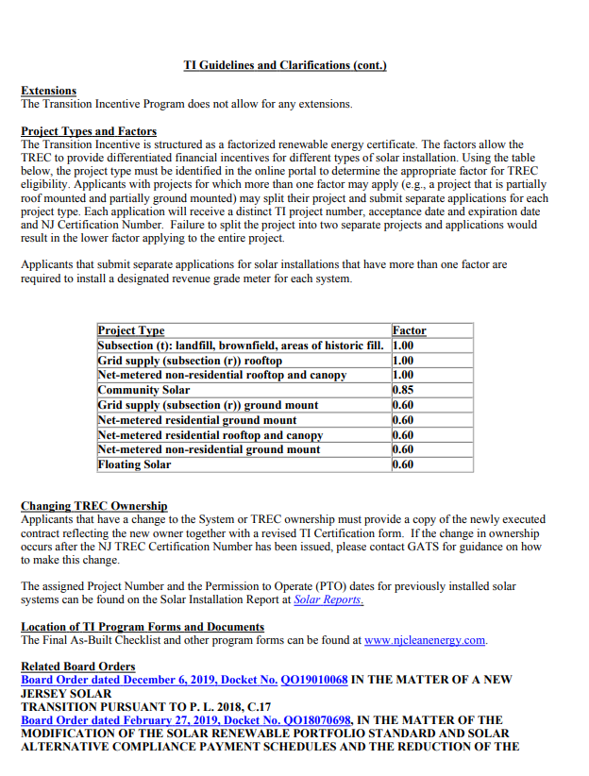



APPENDIX B: PROPOSAL COST AND PRICING SHEET

The PACC is hereby requesting offers for the turkey delivery of engineering, procurement, and construction for a photovoltaic system at their Hinson Waterfront Garage, located at 10 Delaware Avenue, Camden, NJ 08102. The PACC requires PPA rates as well as pricing for cash purchase of each proposed PV system in order to weigh the best financial and economic option for the Authority. Additionally, the project was submitted under the Transition Incentive (TI) program through the Clean Energy Program.

The conditional approval stipulates that projects that were submitted and approved **must reach Permission to Operate (PTO) by 9/22/2022**. With the unwavering deadline on 9/22/2022, the PACC also requests PPA pricing and firm cash pricing under a Successor Solar Incentive Program (SuSI) scenario.

To be considered, respondents are required to include PPA pricing and firm cash pricing under a TI scenario and under a SuSI scenario.

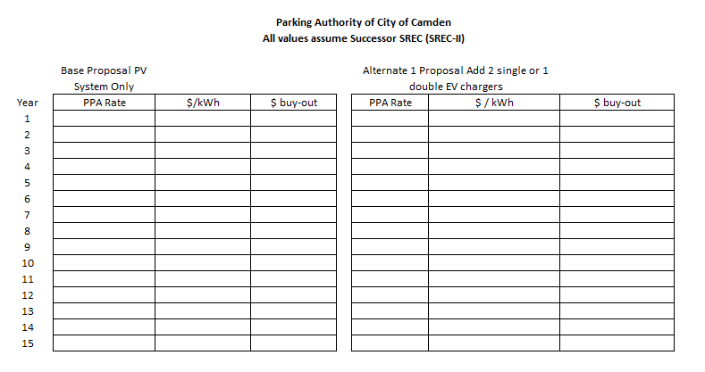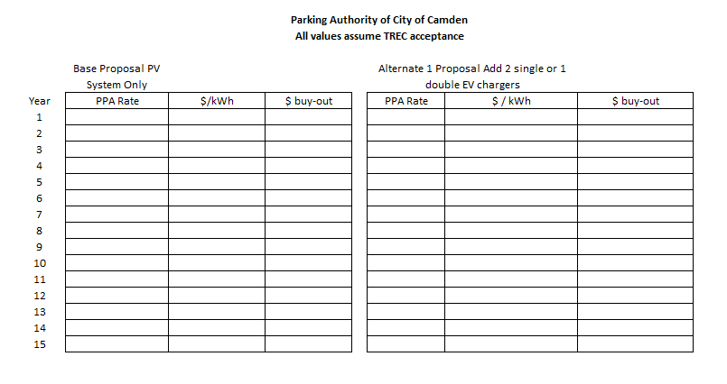

APPENDIX C: PROJECT CONCEPT MAP

## 

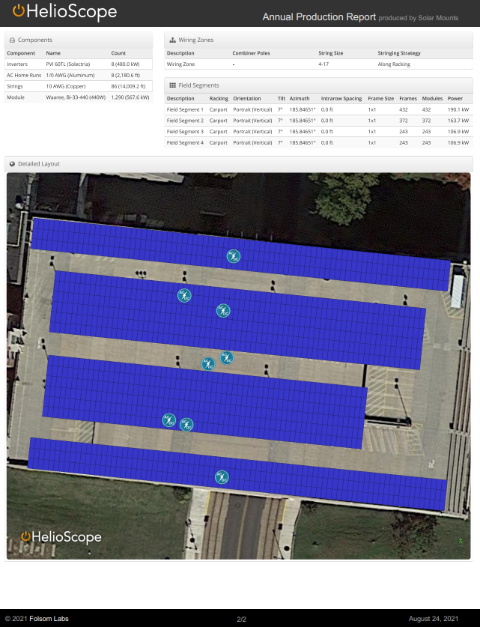

**Hinson Waterfront Garage 10 Delaware Ave, Camden, NJ 567 Kw**

APPENDIX D: UTILITY INFORMATION

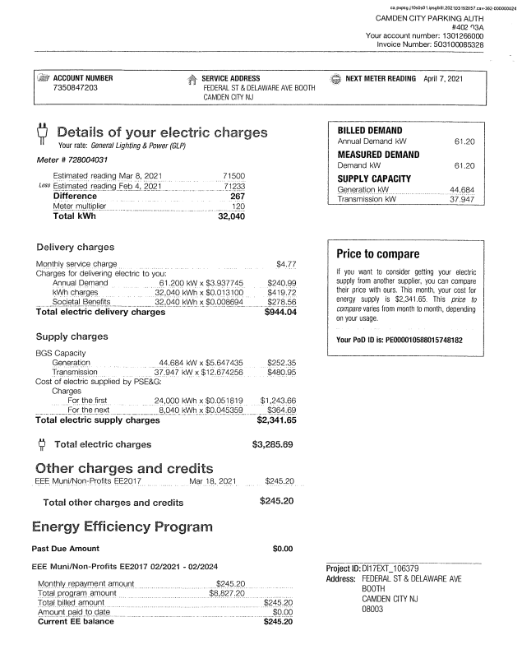

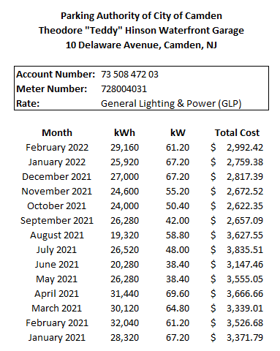

APPENDIX E: ELECTRICAL VEHICLE CHARGING TECHNICAL SPECIFICATIONS

**Technical Specifications for Electric Vehicle Charging**

**Parking Authority of City of Camden (PACC)**

The Parking Authority of City of Camden (PACC) desires to receive firm pricing for the turnkey delivery of fully-functioning Electric Vehicle Charging (EVC) equipment. The turnkey delivery of the EVC equipment shall be provided as alternate additions to the PV system “Base Offer”. The PACC may or may not proceed with the installation of EVC equipment.

The following sections identify the Basis of Design for the preferred EVC equipment and specify the minimum technical requirements for the equipment, physical installation, and software operation. All costs for the EVC work included in the RFP shall be the sole responsibility of the proposer and, shall be included in the PPA rate for each Alternate to the PV system Base Offer.

ELECTRIC VEHICLE CHARGING (EVC)

Install EVC equipment including charging cabinets, rectifiers, chargers, dispensers, conduits, and wiring.

Mock-up: Installation of this equipment item requires initial mock-up and acceptance by PACC and their designated representatives.

COMMERCIAL ELECTRIC VEHICLE CHARGING UNIT

*The General Provisions of the Contract, including General and Special Conditions and the requirements consistent with the PV system technical specification. General Component Requirements apply to the Work in this Section.*

* 1. WORK INCLUDED  
     Equipment items as listed below by Equipment Mark Number:

ELECTRIC VEHICLE CHARGING SYSTEM

Installation of equipment with labor, services, and incidentals necessary for a complete and properly operational equipment installation.

Utilities to be roughed in at location reviewed and approved by the PACC and their representatives.

Coordination of equipment, controls, systems, and vehicle to allow for a single user operation of the EVC unit.

ALTERNATIVE BIDS

*Refer to Appendix B Proposal Cost and Pricing Sheet / General Requirements for possible effect on Work of this Section.*

QUALITY ASSURANCE

Experience: Equipment shall be produced by a manufacturer of established reputation with a minimum of five years’ experience supplying specified equipment.

Manufacturer's Representative:

Installation: Provide a qualified manufacturer's representative at site to supervise work related to equipment installation, check out and start up.

Training: Provide technical representative to train PACC’s maintenance personnel in operation and maintenance of specified equipment.

Testing: Provide technical representative for final testing of equipment.

STANDARD AND REGULATORY REQUIREMENTS

Equipment indicated within this specification section shall comply with all applicable national, state, and local codes and regulations, including seismic, fire, and racking codes and regulations. Additional, more specific compliance requirements may be listed under individual equipment headings.

Permitting: Any individual equipment permits required by the local authority having jurisdiction (AHJ) shall be responsibility of the Contractor. The contractor shall obtain all necessary information, provide all necessary documents, and submit for all individual equipment permit as required by the AHJ. Individual equipment permits shall include, but not necessarily be limited to, any deferred equipment submittals, seismic permitting, fire marshal approvals, and equipment installation/start-up permitting.

SUBMITTALS

*Submittal requirements consistent with the PV system technical specifications.*

Product Data:

*Submit Product Data in accordance with Shop Drawings Package/ General Requirements of these specifications consistent with the PV system technical specifications.*

All Product Data submittals shall identify proposed project specific items marked by arrow, circle, underline, reproducible highlight, or other markings clearly discernable by the reviewer, to show which specific items, parts and accessories are being submitted for the project product data review. Non-marked or generic product data submittals with no marks indicating specific items, parts and accessories will be a cause for rejection.

Restrict submitted material to pertinent data. For instance, do not include manufacturer's complete catalog when pertinent information is contained on a single page.

Operation and Maintenance Manual:

Provide a Complete parts list, operating instructions, and maintenance manual covering equipment at time of installation including, but not limited to:

Description of system and components.

Manufacturer's printed operating instructions.

Printed listing of periodic preventive maintenance items and recommended frequency required to validate warranties. Failure to provide maintenance information will indicate that preventive maintenance is not a condition for validation of warranties.

List of original manufacturer's parts, including suppliers' part numbers and cuts, recommended spare parts stockage quantity and local parts and service source.

Assemble and provide copies of manual in 8-1/2 by 11-inch format. Foldout diagrams and illustrations are acceptable. Manual to be reproducible by dry copy method. Provide copies per provisions of Documentation / General Requirements, consistent with the PV system technical specification.

Shop Drawings: *Submit shop drawings in accordance with Shop Drawings Package of these specifications.*

Submitted shop drawings shall be project specific and shall include a minimum 1/8 inch to 1 foot scaled (or larger standard architectural imperial scale), dimensioned, graphical representation of the size, orientation, and location for all instances of submitted

The drawings shall further include dimensions from structural elements or architectural grid lines to each major charging equipment item (EVC unit) operational clearances, locations of any utility service connection points, power and communication output points, mounting requirements, and structural supports required for the submitted equipment.

Manufacturer’s standard installation drawings will be accepted and reviewed but are not considered as a replacement to project specific shop drawings.

Test Procedure and Test Reports:

Testing Procedures and Testing Reports are required for all systems included in this specification. Testing procedures shall be submitted to the PACC and Design Team prior to installation, and shall, at a minimum, outline the manufacturer’s procedure for successful testing of the equipment after installation. Testing Reports shall be record documents of the post-installation test, itemizing the requirements of the Test Procedure and noting if individual requirements were met or not met, with notes and comments as needed. Testing reports shall be provided to the PACC and Design team upon completion of testing, prior to final invoice. Provide duplicates of all test reports as part of the Close-Out Documents.

Required Documents for Permit and Local Jurisdictional Approval:

Where required by local jurisdiction and/or code officials, the contractor/supplier shall be responsible for producing and submitting all documentation required for obtaining all applicable approvals related to the specified equipment. This documentation may include, but may not be limited to, engineered signed and stamped plans, details, anchorage layouts for equipment on stands to show compliance with locally adopted ASCE, seismic, fire, and other codes. A copy of these required documents shall be included with the product submittal to the Design Team/consultant team for their review.

PRODUCT SUBSTITUTIONS

*Follow requirements specified in General Requirements.*

Additional costs resulting from substitution of products, accessories or deviations of operations as described in Section 2, other than those specified, including drawing changes and construction, will beat the expense of the Contractor, captured, and reviewed as part of the shop drawing review. All design deviations of the proposed charging system including operational changes, changes required to electric vehicle mounted equipment and controls, variations to the Remote Dispenser Operating System equipment and controls to be documented on the project specific shop drawings and product data review.

Substitution Approval: Manufacturers listed for each equipment item may bid without prior- submittal authorization for that item. Manufacturers not listed shall submit for approval in accordance with "Instructions to Bidders". Prior to procurement, submittals for each equipment item by Mark Number shall be provided in accordance with General Requirement, as described in and consistent with the PV system technical specification.

WARRANTY

Warrant work specified herein for one year from substantial completion against defects in materials, function, workmanship and charging system operational design.

Warranty shall include materials and labor necessary to correct defects including replacement of charging system operational elements with re-designed components.

Defects shall include, but not be limited to loose, damaged and missing parts and abnormal deterioration of finish, excessive cord wear.

Operational design defects include systemic bent charging and charging communications connector pins, damaged charging cord conductors and internal wiring, breakage and deterioration of charging plug-in mating elements (ports, charging connector) during routine daily use of charging system.

*Submit warranties in accordance with Warranty / General Requirements of these specifications.*

PRODUCT DELIVERY, STORAGE, AND HANDLING

Deliver equipment in manufacturer's containers, appropriately packaged and/or crated for protection during shipment and storage in humid, dusty conditions. Equipment shall be stored per manufacturer's recommendation.

Indelibly label all containers, including those contained in others, on outside with item description(s) per title and Mark Number of this specification.

Provide equipment and materials specified complete in one shipment for each equipment item. Split or partial shipments are not permissible.

LABELING

Manufacturer shall securely attach in a prominent location on each major item of equipment the following labels:

A non-corrosive nameplate showing manufacturer's name, address, model number, serial number, and pertinent utility or operating data.

All NFPA and /or OSHA compliant labels as required by those codes, including but not necessarily limited to labels indicating safety alerts, high voltage warnings, and arc flash warning.

Matching labels on each Circuit Breaker / Load Center and Dispenser that clearly identifies which circuit breaker controls which EVC.

PRODUCTS

CHARGING SYSTEM

Equipment Mark Number: PACC EV ##

General:

Description:

A stationary upright dispenser and corded handheld plug capable of being manually connected to the charging port of Electric Vehicles (EVs), and then automatically charging the connected EV utilizing electrical power.

Coordination:

Specification information indicated herein is intended as general requirement only. Final design of the system shall be by the proposer and shall be presented in the project specific shop drawings in coordination with the interconnection and installation of the proposed Photovoltaic (PV) system at the PACC’s Hinson Waterfront Garage, located at 10 Delaware Avenue, Camden, NJ.

Compliance:

The equipment and final design shall comply with the most current editions of all applicable local, state, and federal codes and regulations, including, but not limited to, those listed below:

NFPA 70: National Electric Code (NEC), most recent edition.

SAE J1772: SAE Electric Vehicle and Plug-in Hybrid Electric Vehicle Conductive Charge Coupler, most recent edition.

ANSI/IEC 60529: Degrees of Protection Provided by Electrical Enclosures, most recent edition.

Open Charge Point Protocol OCPP 1.6 or higher to allow charger control and monitoring by a third-party charge management system

NFPA 70E: Standard for Electrical Safety in the Workplace, most recent edition.

CFR 1910.147: Code of Federal Regulations, Occupational Safety and Health Standards, General Environmental Controls, The Control of Hazardous Energy (Lockout / Tagout), most recent edition.

Components:

Level II Electric Vehicle Charging (EVC) Unit

All components, interconnecting cabling and conduits between components, software, and accessories for a fully and properly operational device.

Capacities and Dimensions:

Output voltage range at the remote dispenser, nominal: 7.2 kW (240V AC @ 30A)

Required Service Panel Breaker: 40A dual pole (non-GFCI type)

Output power at the remote dispenser, maximum: 7.2 kilowatts (kW)

Input voltage at the EVC: 208/240 AC (VAC)

Input frequency at the DC power cabinet, nominal: 60 hertz (Hz)

Overall dimensions, DC power cabinet, nominal: 71.3” High x 13.7” Wide

Limited variability of sizes and configurations:

Note that EVCs are being located as ground mounted within an existing and operating public parking garage. While nominal EVC unit dimensions are provided around the EVC basis of design (BOD), alternative EVCs of different sizes, proportions and configurations will be considered provided:

No portion of the EVC or support stand can extend over the edge of the raised concrete curb into the parking stall

A Minimum of one (1) dual-port EVCs or two (2) single-point EVCs are included to meet Alternate 1.

Manufacturers Reference:

Prime manufacturer:

Specifications are based on equipment identified herein by manufacturer's name and model to establish acceptable standards of quality, performance, features, and construction. It should be noted that the ChargePoint equipment is **not required** for a Proposal to be considered by the PACC but rather a Basis of Design (BOD) example of a Level 2 Electric Vehicle Charger (EVC) specification. The PACC will accept other EVC manufacturers provided the equipment submitted by the Proposer meets the minimum technical requirements of the BOD.

ChargePoint, Inc.  
 240 East Hacienda Avenue Campbell, CA 95008-6617 USA

+1.408.841.4500 or  
 +1.877.370.3802 US and Canada toll-free

chargepoint.com

EVC Model: 6-foot Single Port Bollard Networked Station with Concrete Mounting Kit CT4011-GW1

EVC Software and Services: Charge Point Commercial Service Plan CPCLD- COMMERCIAL-5

Inspection

Coordinate location of rough-in work and utility stub-outs to assure match and/or non-interference with equipment to be installed.

Inspect delivered equipment for damage from shipping and exposure to weather. Compare delivered equipment with packing lists and specifications to assure receipt of all items.

INSTALLATION

A Minimum of 1 (one) dual-port EVCs or two (2) single-point EVCs are included to meet Alternate 1 requirements for the project at Hinson Waterfront Garage.

Perform work under direct supervision of Foreman or Construction Superintendent with authority to coordinate installation of scheduled equipment with Design Team.

Coordinate work with Manufacturer’s Representative indicated in Warranty of this specification section.

Install equipment in accordance with plans, shop drawings, and manufacturer's instructions:

Initial PACC mockup for positioning: At a parked EV charging position to be identified by PACC, provide installation mockup of EVC unit with actual charging cord, attached charge connector plug to allow for testing and proofing of charger operation and ergonomics.

Positioning: Place equipment in accordance with any noted special positioning requirements generally level, plumb and at right angles to adjacent work.

Fitting: Where field cutting or trimming is necessary, perform in a neat, accurate, professional manner without damaging equipment or adjacent work.

Anchorage: Attach equipment securely to floor, per manufacturer’s instructions and as directed by Design Team, to prevent damage resulting from inadequate fastening. Installation fasteners shall be installed to avoid scratching or damaging adjacent surfaces. Upon completion of work, finish surfaces shall be free of tool marks, scratches, blemishes, and stains.

TESTING

After final connections are made and prior to authorizing payment, specified equipment shall be tested for compliance with specification in the presence of the Design Team using acceptance procedures provided by the manufacturer.

Final testing and post installation inspection are required and shall be performed by the manufacturer or the manufacturer’s designated representative only. Final testing and inspection shall not be performed by the installer, unless the installer is also the manufacturer.

Manufacturer / Installer shall provide a testing procedure and checklist that indicates proper testing of all major functions of the equipment. This procedure and checklist will form the basis of the testing process.

CLEANUP

At the conclusion of every workday (scheduled or un-scheduled) the contractor is required to restore all work areas to “broom clean” condition.

Touch-up damage to painted finishes.

Wipe and clean equipment of any oil, grease, and solvents, and make ready for use.

Clean area around equipment installation and remove packing or installation debris from job site.

Notify Design Team for acceptance inspection.

TRAINING

Direct the technical representative to provide specified hours of training to designated PACC's maintenance personnel in operation and maintenance of the following equipment. Coordinate, with PACC, training schedule and list of personnel to be trained.

EVC equipment, software monitoring and management system and appurtenances.

Hours Required: 8

Software Subscription minimum requirements.

The EVC unit operating management and monitoring software must provide the following functionality:

PACC shall be enabled to set the price that drivers pay to use charging stations based on energy cost, duration, time of use, session length or driver group. Funds collected from drivers are electronically transferred to a designated bank account.

Advanced access controls to manage which drivers can access stations and when.

Must provide charts and analytics, to summarize trends for planning and management reporting.

Waitlist function to make charging more convenient by notifying drivers when a charging spot becomes available for them and holding it until they can plug in their vehicle.

Capability to integrate with fleet fuel cards, telematics and asset management systems simplifies.

A valet feature that automatically indicates (to PACC staff) when cars are completed with charging so they can be notified/charged.

A graphical dashboard showing real-time status and a detailed map, making it easy to manage stations from PACC desks or mobile phones.