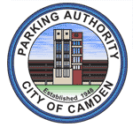

PARKING AUTHORITY OF THE CITY OF CAMDEN
REGULAR MONTHLY MEETING
OCTOBER 22, 2012

OPEN PUBLIC MEETING STATEMENT

The Regular Monthly Meeting of the Parking Authority of the City of Camden was legally advertised in the Courier-Post Newspaper and the meeting notice statement and agenda were posted on the bulletin board in the lobby of City Hall on Thursday, October 18, 2012 @ 2:44 P. M.
A copy was also delivered to the Press Room in City Hall (in compliance with the Open Public Meetings Law PL 1975, e. 231.)

