08/27/12 R2012-8:76

RESOLUTION
OF
THE PARKING AUTHORITY OF THE CITY OF CAMDEN

AUTHORIZING THE PARKING AUTHORITY TO AUCTION EQUIPMENT THAT IS NO LONGER REQUIRED OR USEFUL TO THE OPERATIONS OF THE PARKING AUTHORITY

WHEREAS, the Parking Authority of the City of Camden has identified the attached list of equipment as surplus and is no longer required or useful to the operations of the Parking Authority of the City of Camden; and

WHEREAS, the Parking Authority City of Camden seeks to obtain compensation for the surplus equipment to the extent possible;

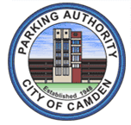
NOW THEREFORE BE IT RESOLVED: that the Commissioners of the Parking Authority of the City of Camden do hereby authorize the sale/disposition of said equipment by Public Auction as per the attached terms of sale.
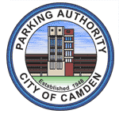

Page 2 of R2012-08:76

VOTING RECORD

Commissioners

_____/YEAS_____/NAYS_____/ABSTENTIONS_____/ABSENT

Angel L. Alamo

Michael B. Jordan

Sanders Kendrick, Jr.

Falio Leyba Martinez

Barry Moore

______________________________
Angel L. Alamo
Chairman

SEAL

I hereby certify that the foregoing is a true copy of the Resolution adopted by the members of the Parking Authority of the City of Camden at a Meeting held on August 27, 2012.

_____________________________________
Daniel A. Bernardin, Esq.
Board Solicitor

